Automatic Layout of Schematic Diagrams

Mini Thesis

Jonathan Stott

The University of Kent

28 July 2004

Abstract
This mini thesis is a summary of my first year. It includes a introduction to the area in which I am currently working, a background of related work which I have read, a description of work to date and an overview of future work which I am currently working on or plan to work in during the final years. A tentative summary of my final thesis is also given.
Contents
1 Introduction 4
1.1 Graph Drawing 4
1.2 Metro Maps 4
1.3 Organisation of the Mini Thesis 6
2 Background 7
2.1 Force Directed Graph Drawing Methods 7
2.1.1 Spring Embedder 7
2.1.2 Force Directed Metro Map Layout 8
2.2 Orthogonal Graph Drawing Methods 8
2.3 Graph Drawing Aesthetics 10
2.4 Optimisation Methods for Drawing Graphs 11
2.5 Schematic Diagram Layout Methods 11
2.6 Map Labelling 12
2.7 Metro Map Metaphor and Schematic Diagrams 13
3 Metro Map Layout Using Multicriteria Optimisation 14
3.1 Introduction 14
3.2 Method 15
3.2.1 Schematics Software Tool 15
3.2.2 Preprocessing – Graph Contraction 15
3.2.3 The Hill Climbing Optimizer 16
3.2.4 Aesthetic Metrics 16
3.2.5 Dealing with Over-length Edges 18
3.2.6 Labelling 19
3.3 Examples 19
3.3.1 Atlanta MARTA Rail Map 20
3.3.2 Washington Metro 21
3.3.3 Sydney Suburban CityRail 22
3.4 Conclusion 24
4 Future Work 26
4.1 Improvements to Existing Algorithm 26
4.1.1 Performance and Optimisation 26
4.1.2 Consideration of Highly Connected Maps 26
4.1.3 Improved Preservation of Geographic Interrelationships Between Nodes 26
4.1.4 Labelling 26
4.2 Alternative Methods for Drawing Metro Maps 27
4.3 Application of Metro Maps to Abstract Metaphors 27
4.4 Characteristics of Existing Metro Maps 27
5 Thesis Outline 28
5.1 Chapter 1: Introduction 28
5.2 Chapter 2: Background 28
5.3 Chapter 3: Method 28
5.4 Chapter 4: Evaluation of the Method 28
5.5 Chapter 5: Conclusions and Possible Further Work 28
6 References 29

Index of Figures
Figure 1.1. London Underground diagram from 1932 by F. H. Stingemore. 5
Figure 1.2. Harry Beck's first schematic London Underground diagram from 1933. 5
Figure 1.3. London Underground diagram in 2004. 5
Figure 2.1. Randomised graph of K₆. 7
Figure 2.2. Embedded graph of K₆ using the basic spring embedder. 7
Figure 2.3. An orthogonal graph. 9
Figure 2.4. A planar orthogonal graph. 9
Figure 2.5. Three route maps rendered to show the same route[1]. The left-hand image uses a standard geographic map; the middle image is a schematic sketch while the right-hand image is a computer-generated schematic. 12
Figure 3.1. Screenshot of the schematics software tool 15
Figure 3.2. Line straightness metric example 18
Figure 3.3. Bridge edge example 19
Figure 3.4. Initial layout of the Atlanta MARTA Rail map 20
Figure 3.5. During the first iteration, before over-length edges are processed 20
Figure 3.6. After the first iteration 21
Figure 3.7. Final layout of the Atlanta MARTA Rail map 21
Figure 3.8. Final layout of the Atlanta MARTA Rail map with labelling 21
Figure 3.9. Initial layout of the Washington Metro Map 22
Figure 3.10. Initial layout with contracted edges (dotted edges represent contracted edges) 22
Figure 3.11. Final layout of the Washington map 22
Figure 3.12. Sydney CityRail map 23
Figure 3.13. Initial layout of the Sydney CityRail map 24
Figure 3.14. Final layout of the Sydney CityRail map using contracted edges 24
Figure 3.15. Final layout of the Sydney CityRail map without using contracted edges 24

Introduction
This mini thesis is intended as an overview of my work to date, covering the last nine months. The main emphasis of my work so far has been with regard to the automatic layout of metro maps, a method for which is presented later in this work. I have also undertaken a large amount of reading of the related subject of graph drawing and also a few existing approaches to using metro maps (as a means to navigate abstract metaphors).

Graph Drawing
A graph is a representation of a grouping of related objects, such that relationships between related objects (the nodes) are shown by edges connecting the nodes. Graph drawing is the process whereby an abstract graph is visualised in a concrete embedding.
There are many approaches used to draw graphs, a number of which are investigated later in this mini thesis. They all generally have the aim of producing graphs that are drawn to improve the readability of the graph in order to make it easier to convey the information that the graph contains. However, this is a very subjective process and one which makes the field of graph drawing so appealing. To this end, a number of empirical studies have been undertaken to try to quantify aesthetic features of graphs that contribute to a good drawing.

Metro Maps
Metro maps will be familiar to anyone who has visited many cities around the world. The first, and probably the most famous, is the London Underground map [29], which was originally designed in 1933 by Harry Beck.
Motivation for providing a schematised diagram came about by the rapid expansion of the London Underground network in the 1930s. This meant the existing attempts at mapping the network (as in Figure 1.1) were becoming increasingly difficult, especially with regards to coping with the scale of the network. Harry Beck’s first schematic diagram appeared in 1933 (see Figure 1.2). Curiously, at the time it proved unpopular with many people and critics complained that the diagram mislead people over the scale of the network, in that it gave the impression that remote stations were closer to London than they first appeared. However, the map has since caught on and is used by the 19 million people who use the Underground each year.
The current map is shown in Figure 1.3. A comprehensive history of this map, including a detailed investigation of the design issues involved in producing the map is given in [20]. A thorough evaluation of all the current metro system maps around the world is detailed by Ovenden [30].
Metro maps tend to be very characteristic. Indeed, it has been said that the London Underground map is almost iconic – to the extent that one can buy mugs, t-shirts and even umbrellas with the Underground map on from London souvenir shops!

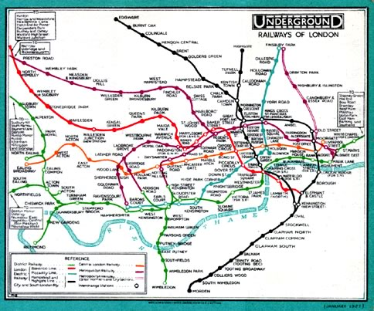  Figure 1.1. London Underground diagram from 1932 by F. H. Stingemore. | 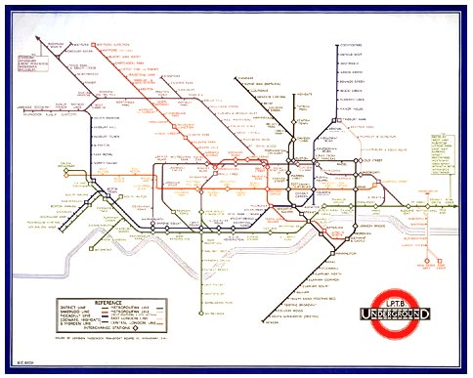  Figure 1.2. Harry Beck's first schematic London Underground diagram from 1933.

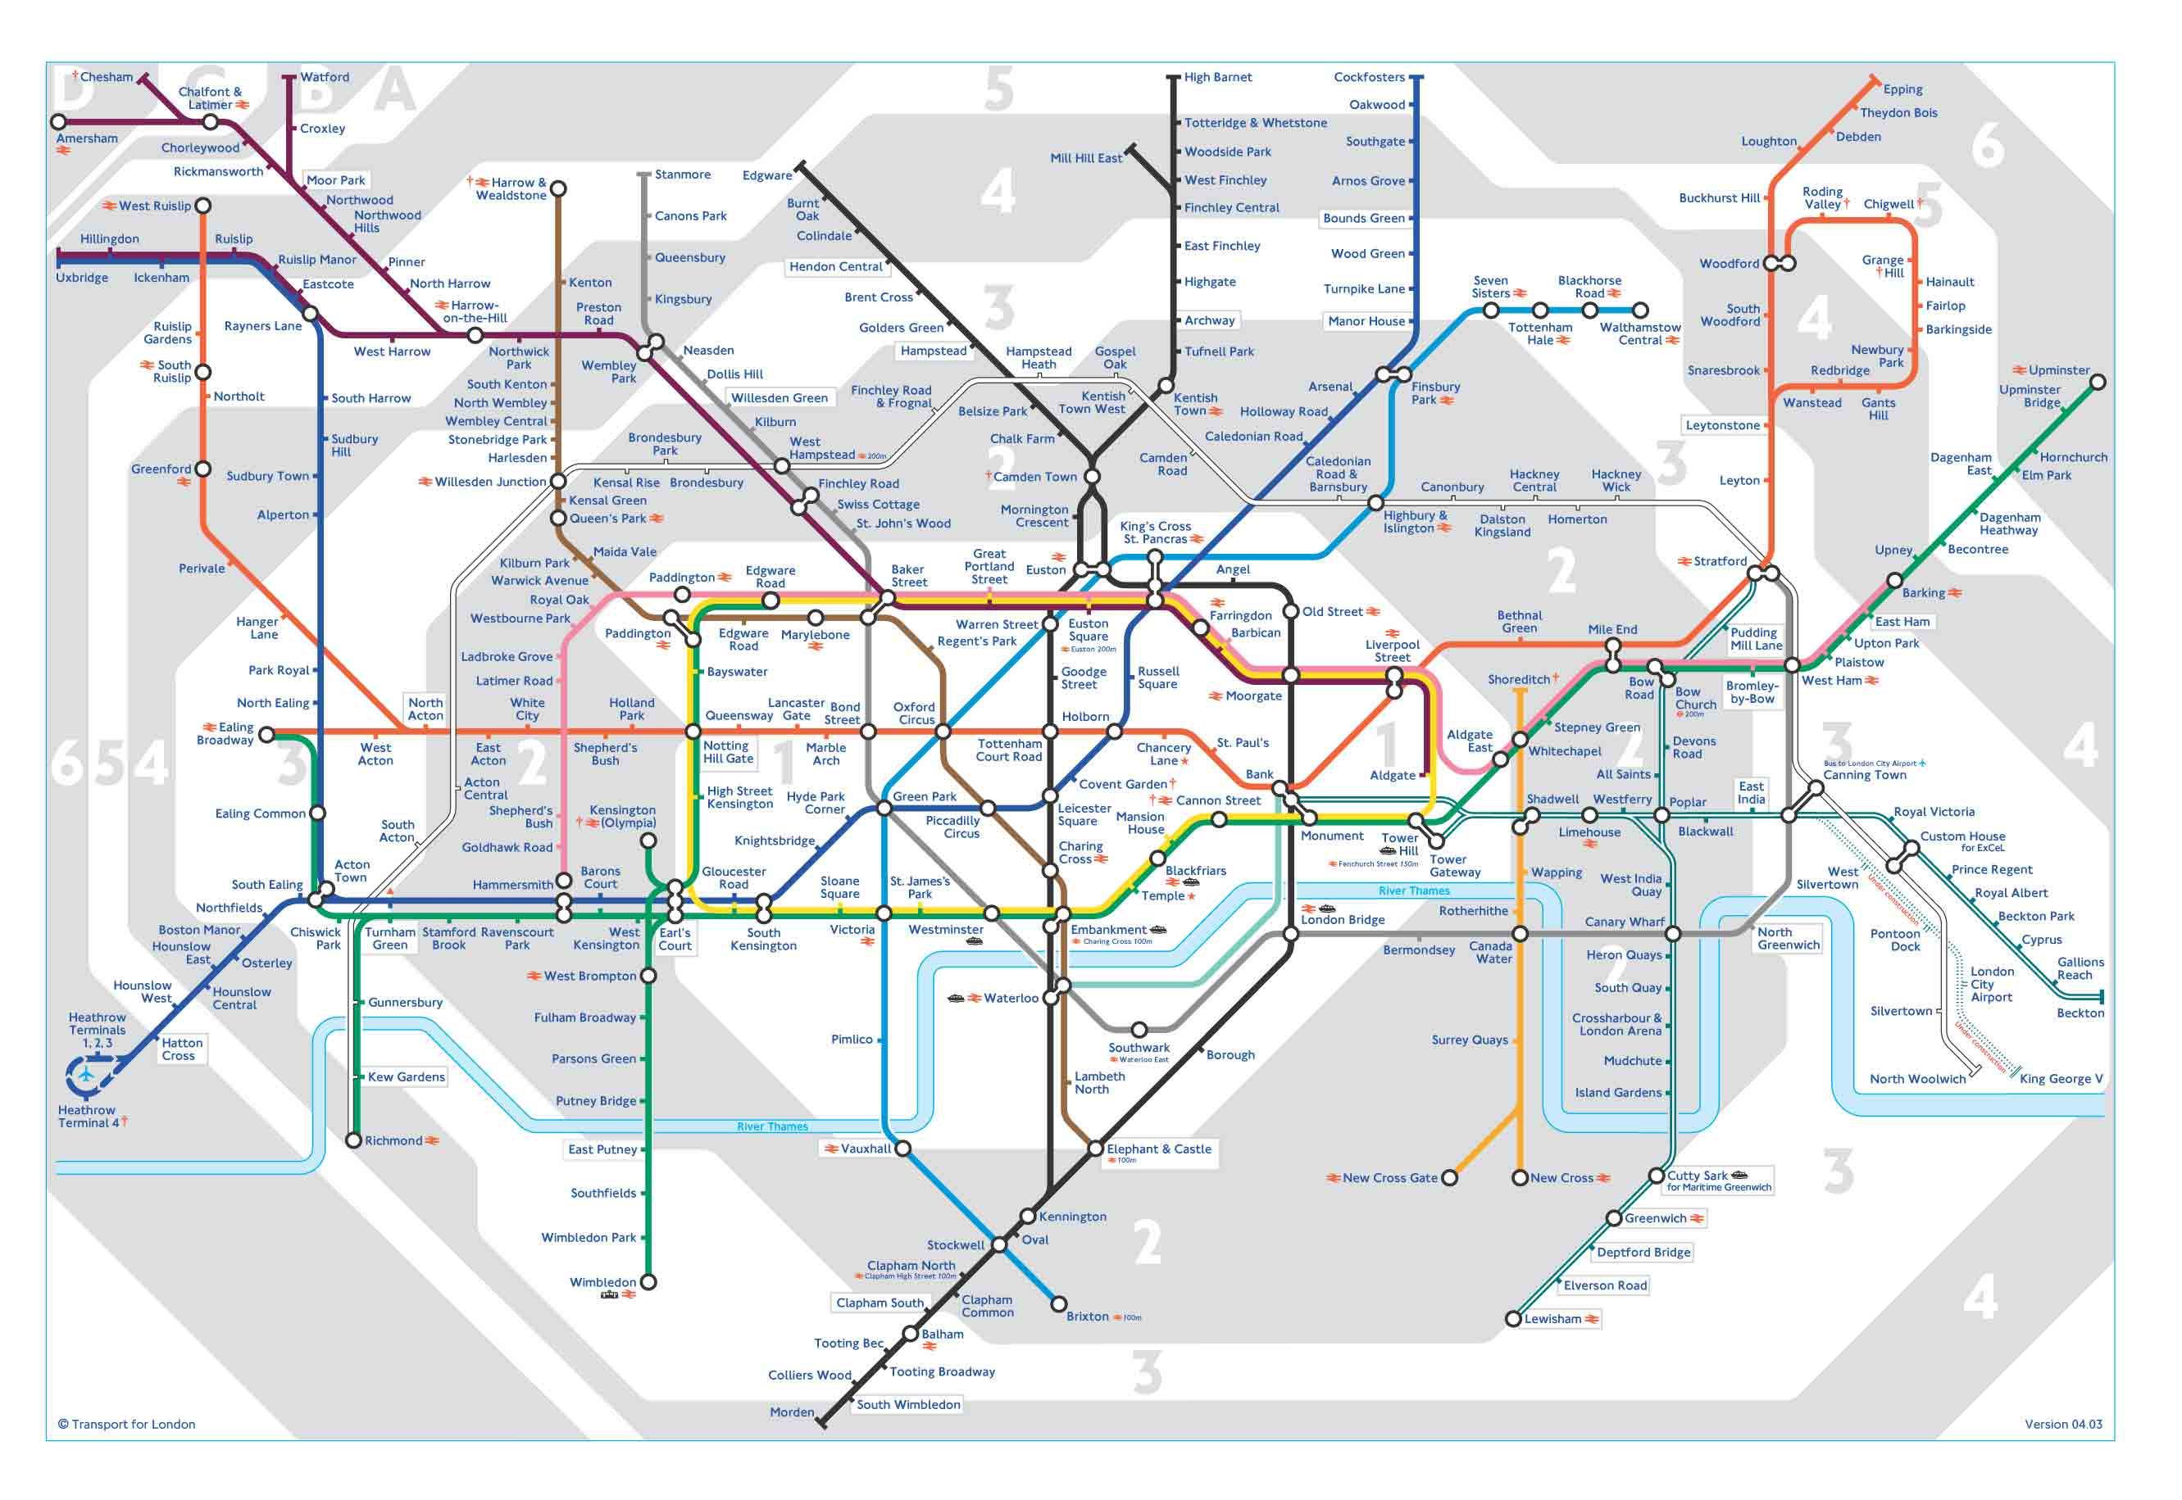
Figure 1.3. London Underground diagram in 2004.
A number of aesthetic features of metro maps enhance their readability so that people using the metro find it easy to plan routes from the start of their journey to their destination. It is generally also easy to see where changes at interchange stations are necessary.
Metro maps aren’t just used to depict metro systems. Bus systems, such as the one in London use similar maps (called spider maps in the case of London buses) to show bus lines [28] and the metro map is also used as a metaphor to aid abstract navigation [33][37]. Also related to metro maps are other schematic maps such as maps that depict larger train networks, such as the British railway network [8] and also as layouts of, for example, utility networks [27].

Organisation of the Mini Thesis
Chapter 2 details the background to my work, including a survey of work on drawing graphs and other approaches to laying out schematic diagrams. Chapter 3 covers the work completed during the first year and Chapter 4 describes future work that I plan to undertake. An overview of the expected contents of the final thesis is given in Chapter 5.

Background
This chapter introduces the various background material which is relevant to my area of research. It starts with describing a number of different methods for graph drawing and laying out schematic diagrams [2][3]. Aesthetics of graphs is very important, so a number of papers that consider graph aesthetics from an empirical point of view are described. Map labelling and the application of the metro map metaphor to visualisation of abstract concepts are also covered.
Graph drawing is a generally difficult problem – many aspects are NP-complete [19][32]. Therefore, acceptable heuristics are generally required to find good drawings of graphs.

Force Directed Graph Drawing Methods
Natural physical models appear to offer an excellent basis for a number of heuristics for the layout of graphs. Examples include a mechanical model of springs and electrical forces and a physical model based on simulated annealing. Section 2.1.2 introduces the previous work on the automatic layout of metro maps which uses a force directed approach.

Spring Embedder
The spring embedder [13] uses a model of springs and electrical forces. In this case, nodes are represented as rings and edges as springs attached to the rings. The force of the spring causes connected nodes to attract each other (the force is calculated in terms of the logarithm of the distance between the nodes). A repulsive force is also applied using an inverse square law. This ensures that non-adjacent nodes are kept apart. The forces should allow for a reasonable separation of the nodes while edges are kept to be of roughly similar length.
The spring embedder typically starts with a random embedding of the graph and a number of iterations are applied until some equilibrium is reached. For larger graphs, a greater number of iterations is typically required. Figure 2.4 and Figure 2.5 show how the spring embedder lays out the graph of K₆.
Figure 2.4. Randomised graph of K₆. | Figure 2.5. Embedded graph of K₆ using the basic spring embedder.
Fruchterman and Rheingold [18] extend Eades’ algorithm by basing the force calculations on an optimal distance k which depends on the number of nodes and the area of the drawing area.
Kamada and Kawai show another approach to force directed graph drawing [24]. Their approach uses the relation between the graph theoretic distance and the geometric distance between nodes to produce good embeddings. The algorithm works particularly well for symmetric graphs and is relatively good at minimising edge crossings. They use Floyd’s shortest paths algorithm [15] to find the minimum graph theoretical distances which runs in time (faster shortest path algorithms are available); the other parts of their algorithm run in either linear or constant time.
There are many other force directed algorithms, including an algorithm based on magnetic springs [41], an adaptive approach (which is generally faster) [17] and a method that ensures that edge crossings properties are preserved [5].

Force Directed Metro Map Layout
There is one approach to laying out metro maps using a force directed heuristic by Hong et al. [21][22]. In their paper, they put forward five different layout methods which use combinations of spring-based algorithms. The algorithms used are the GEM algorithm [17], the PrEd algorithm [5] and a magnetic spring algorithm [41]. Some of their methods include a preprocessing step which involves simplifying the graph by removing all nodes with only two incident edges. They also include a final step of labelling the graph which uses a combinatorial approach to try to achieve a labelling with as few overlaps as possible.
They analyse their methods with regards to a set of five criteria: 1) that each line should be drawn as straight as possible, 2) that there should be as few edge crossings as possible, 3) that labels should not overlap, 4) that edges should be drawn orthogonally or at 45° and 5) that each line should be drawn with a unique colour. They claim that their results satisfy the first four of these criteria (they don’t consider the fifth criteria in any great detail).
As their methods were progressively refined to the application, they produced increasingly better graphs. However, the results were hampered as the geographic topology of the maps was not at all considered. This is because they started with a random embedding of the graph, as is common with many other force-directed graph drawing algorithms. They argue that people using metro systems are not concerned with the real topology of the system, but this is clearly not the case when one is using a “northbound” train and the map shows the line going from top to bottom (it seems reasonable to assume that people perceive north as being “up” and south as being “down”).
The results they present generally satisfy their first four criteria. Their best method is their fifth method which seems to produce the most aesthetically pleasing graph. However, the graphs suffer from a number of flaws, most notably the irregular spacing of nodes – some are very close together (so close that you can’t discern any edge between them) and others are very far apart. They also don’t consider drawing whole train lines; each pair of connected nodes are connected by only a single edge when in many real-world examples, many edges (different train lines) might need to be drawn between nodes. Their labelling step produces an acceptable labelling, but many metro maps tend not to use diagonal labels as horizontal labels are most likely easier to read. The main problem is that their resulting graphs generally have very few features (if any) in common with existing metro maps. This is evidently a problem if the maps were to be used as a replacement for the existing maps – people would most likely have issues if the mental map of the map is too greatly changed.

Orthogonal Graph Drawing Methods
Orthogonal graph drawing is mainly concerned with drawing graphs where edges are restricted to horizontal and vertical lines. In many approaches, polylines (lines with more than one straight segment) are allowed where a line with a single segment cannot be drawn orthogonally (see Figure 2.6). As such, it is particularly interesting with regards to metro map layout where a predominantly orthogonal embedding is required. Orthogonal diagrams also have applications outside of graph drawing, particularly in the field of VLSI (very large scale integration) design and in diagrams used for information systems design such as entity relationship diagrams. Many orthogonal graph drawing algorithms are called dynamic – that is they construct an embedding from the bottom up rather than considering the whole graph in a top-down approach.
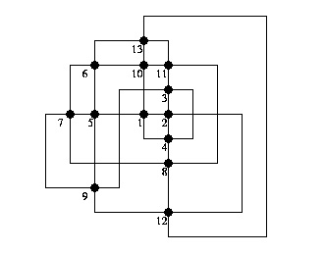
Figure 2.6. An orthogonal graph.
A number of approaches are based on the Kandinsky model which dictates that a graph should be drawn with nodes represented as finite-sized rectangles and edges should be drawn using only horizontal and vertical components. Tamassia [43] presents an algorithm for embedding a planar graph on a grid in such a way as to minimise the number of bends. A planar graph is a graph which can be drawn without edge crossings as shown in Figure 2.7. Highly connected graphs are not catered for – the maximum degree of a node for an orthogonal drawing using this algorithm is four. (The degree of a node is the number of edges which are incident to the node. For example, the degree of node 1 in Figure 2.6 above is 4.) The algorithm runs in time where n is the number of nodes in the graph. The algorithm is based on network flow techniques where the flow is related to the number of bends on an edge and the capacity of nodes (how many more edges could be added incident to the node without exceeding the maximum of four incident edges); the aim of the algorithm is to find the minimum cost flow for the graph which should be that with the fewest edge bends. Later in the paper, an extension to k-gonal graphs is given. A k-gonal graph is one where edges are formed of polylines with segments at multiples of degrees. An orthogonal graph is therefore one where . This is a relatively simple extension of their algorithm and one which would prove useful for metro map layout as metro maps tend to be 4-gonal. (The maximum degree graph that Tamassia’s algorithm handles is therefore equal to 2k.)
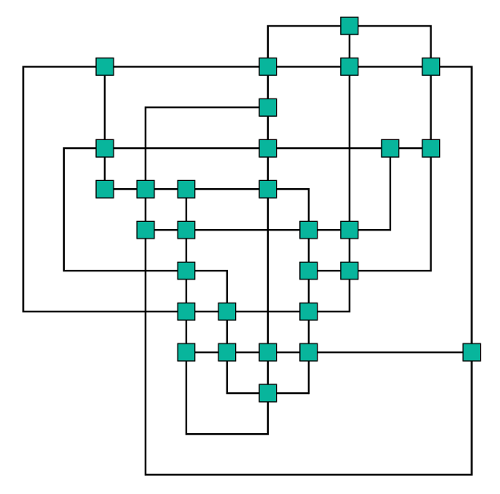
Figure 2.7. A planar orthogonal graph.
Fößmeier and Kaufmann [16] extend Tamassia’s algorithm to handle graphs with degree greater than 2k. They do this be extending Tamassia’s representation. They show an algorithm which first creates a nearly orthogonal representation in time. The nearly orthogonal representation is then used to create an embedding on the grid using a similar compaction algorithm to Tamassia. To be able to draw high degree nodes, large nodes are represented by 8s smaller nodes (where s is the length of the side of the node). Larger nodes are preferred over increasing the number of bends (smaller nodes would be possible but only by increasing the number of bends in the graph).
Another algorithm is given by Papakostas and Tollis in [34]. This algorithm also considers graphs with nodes of degree greater than four, but is more general as it also takes into account simple non-planar graphs. They use three algorithms to size the nodes (taking into account the degree of the node), number and group the nodes into a particular order for processing and the placement of the nodes such that the increased size of the nodes is taken into account. Nodes are paired together so that edges between pairs of nodes can share a row or column. The algorithm is able to produce an embedding of a graph in time where e is the number of edges in the graph. Maximum bounds on the size of the graph can be given in terms of the number of edges and there will not be more than e bends as each edge has at most one bend. However, the resulting embeddings tend to have a relatively high number of edge crossings and a planar embedding for a plane graph may not necessarily be found.
Brandes et al. [6] use a non-dynamic algorithm for drawing graphs where a previous embedding (possibly a rough sketch) is known. The Kandinsky model is again used. The graph is planarised by inserting dummy nodes at edge crossings. The use the concept of ‘readability’ – the total number of bends in the graph – and ‘stability’ – by how much the angles of the final embedding differ to the sketch. Their algorithm is claimed to run in time which is very fast. They claim to maintain stability further by attaching nodes at the extremity of the graph to a bounding box surrounding the graph. After the algorithm has completed, the dummy nodes are removed and a compaction step is used to minimise the area of the graph. This paper is of particular interest as it particularly interested in embedding schematic diagrams.
An interesting paper by Six, Kakoulis and Tollis [38] deals with post-processing of orthogonal embeddings of graphs. This is done by considering a number of cases where improvements could be made, such as by straightening out U-turns, removing superfluous bends, moving degree two nodes to improve their placement, removing self-crossings of edges, dealing with stranded nodes and reducing excess area. In general, significant reductions of the area of the graph, the number of edge bends and crossings and the length of edges are produced, resulting in more compact and aesthetically pleasing embeddings.

Graph Drawing Aesthetics
Many graph drawing algorithms make common assumptions that certain aesthetic criteria of the graph have a detrimental effect on the readability of the graph. These criteria include edge crossings, edge length, angular resolution of incident edges, proximity of one node or edge to another node or edge and node/edge occlusion [12]. Little work has been done in order to quantify and justify these aesthetic criteria.
The first attempt at an empirical study into graph aesthetics was by Purchase, Cohen and James [35]. In this work they considered the symmetry of the graph, edge crossings and edge bends, but don’t consider other metrics such as node distribution or edge length. They conclude by saying that attempting to minimise edge crossings and edge bends makes a significant positive effect on the aesthetic quality of a graph layout. A later paper by Ware, Purchase, Colpoys and McGill [45] contributes to this work by measuring the aesthetic quality of a graph based on the time taken for shortest paths to be found. They conclude that the continuation of edges (where edges pass through nodes as straight as possible) contributes to the quality of the graph when it is used for finding shortest paths.

Optimisation Methods for Drawing Graphs
A number of other graph drawing methods based on optimisation exist including a heuristic optimisation approach [44], an approach using genetic algorithms [7] and the use of simulated annealing [11]. Optimisation is a process whereby incremental improvements are made to a graph. Each successive iteration should produce a more optimal graph (in most cases – some algorithms occasionally allow less optimal graphs in order to avoid local minima).
Tunkelang [44] takes the approach of creating an aesthetic cost function which is then minimized using a local optimisation procedure. The algorithm is flexible by nature of the way in which the aesthetic cost function is modular. The cost function used by Tunkelang is based on three aesthetic criteria, namely: uniform edge lengths, even distribution of nodes and a minimal number of edge crossings. A naïve implementation of the cost function runs in time where e is the number of edges in the graph; this can be improved to a linear function by not recalculating the cost function from scratch each time. The local optimisation procedure involves examining the locality of a node to see whether a better position can be found. The algorithm is capable of producing acceptable embeddings for moderately sized graphs but struggles with large and dense graphs.
Simulated annealing is another approach to drawing graphs. It is based on physical processes of the way that liquids cool into a crystalline form (annealing). This uses the analogy that the minimum energy state of the system (the crystal state) is equivalent to the minimum energy of a simulated annealing system. Davidson and Harel demonstrate an algorithm which is based on simulated annealing [11]. As with force directed drawing algorithms, they start with a random embedding of the graph and iteratively generate an improved embedding. The simulated annealing process produces a erratic improvement with some chance of subsequent iterations being apparently worse than the previous iteration. This has the advantage that it is possible to escape from local minima in the search space. Results are reasonably comparable to that of force directed methods, but the running time of the algorithm is generally poor, especially for large graphs (over sixty nodes).

Schematic Diagram Layout Methods
There have been a few papers which are concerned with the schematisation of route maps. These normally involve a process of cartographic generalisation such that the essential information for following a route is preserved (such as the intersections and approximate direction) while exaggerating distances to make the schematic cleaner and easier to read (see Figure 2.8). This is particularly useful for route-planning applications and especially so with today’s modern in-car satellite navigation devices where the aim is to communicate to the driver a route as quickly as possible.

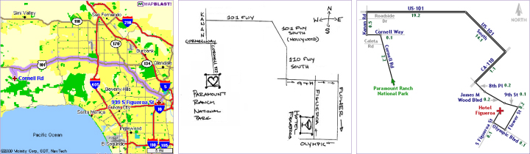
Figure 2.8. Three route maps rendered to show the same route[1]. The left-hand image uses a standard geographic map; the middle image is a schematic sketch while the right-hand image is a computer-generated schematic.
Agrawala and Stolte describe the LineDrive system to generalise and schematise route maps using three types of generalisation [1]. The aspects of the map which are generalised are:
- Generalisation of the length of roads. Shorter roads are drawn longer and longer roads are drawn shorter so that routes involving roads with lengths that differ by several orders of magnitude to be drawn on a compact schematic
- Angle generalisation. Very acute angles at intersections are made more obtuse and roads are aligned with the horizontal or vertical axis
- Shape generalisation. The exact meandering of a road is not important, so the shape of the road is straightened out.
Special care is taken to ensure that the topology of the map is preserved in the schematic, so that intersections, turn direction and the overall route shape are all maintained.
Another approach uses an algorithm for generalising the shapes of curves in a schematic diagram by eliminating unnecessary curves (in a similar way to the shape generalisation part used by Agrawala and Stolte) [4]. Casakin et al. [9] provide a taxonomy of various aspects of schematisation of route maps (particularly intersections) and use their taxonomy to provide an empirical assessment of schematised graphs. Yates and Humphreys [47] give a discussion of various aspects of schematic diagrams and show a prototype (which uses a heuristic provided as a sample applet in the Java 1.1.6 SDK).

Map Labelling
In many fields, such as cartography, labelling a map or diagram is an essential part of drawing the diagram. Typically, when labelling maps and diagrams, three types of labels are needed: node labels (which label point features, such as cities or stations on a railway), edge labels (which label such things as roads, railways or rivers) and area labels (for labelling oceans or countries).
Point feature label placement is discussed in detail by a survey by Christensen, Marks and Shieber [10]. Typically, labels are placed in one of a finite number of positions (the labelling space) surrounding a point feature (or with a near infinite number of positions by sliding a label around the point feature as described in [26]). An order of preference is usually specified as to which positions a label should take up (for example, one could prefer a label to appear to the right of a point feature as opposed to the left).
A number of approaches exist in order to label point features such as performing an exhaustive search, using a greedy algorithm or using a discrete gradient descent algorithm (essentially an optimisation method).
Kakoulis and Tollis [23] show a method for labelling graphical features (of graphs). Their approach firstly reduces the search space for labels by seeing where a label would overlap another node or edge. The subset of potential label positions is then reduced further by detecting overlapping labels. Their results show that their algorithm produces a more efficient labelling for orthogonal diagrams than previous attempts. They also say that the size of labels is a significant factor in being able to produce a successful labelling of a graph.

Metro Map Metaphor and Schematic Diagrams
The metro map is a good metaphor for visualisation of many other concepts. Sandvad et al. [37] use a metro map metaphor as a basis for the visualisation of non-geographic information. Nesbitt [33] also uses the metaphor as a means for visualising abstract concepts such as the recommended reading of a thesis where lines represent key trains of thought and stations represent individual ideas.
Lauther and Stübinger [27] present a demonstration of software which is capable of laying out schematic diagrams using a force-directed approach with the aim of visualising cable plans schematically.

Metro Map Layout Using Multicriteria Optimisation

Introduction
Metro maps, or public transport schematics, are familiar to most people. Many cities have underground metros or above ground tram networks which are usually represented by a schematic map. The map simplifies the true geographic layout of the network by straightening lines and evenly distributing stations along the lines [30]. These maps take inspiration from what is considered the first such schematic, developed by Harry Beck for the London Underground [20]. Travellers find it easier to use such a simplified map to plan routes between start and destination stations.
However, these schematics are typically created by hand taking a large amount of effort. The goal of our research project is to address the metro map layout problem, where we attempt to automatically generate a schematic for a metro map.
We have approached the problem by using a hill climbing multicriteria optimization technique. Multicriteria systems have been seen before in other graph layout applications [11] and a number of metrics have been investigated [3][25]. In our case we represent a metro map as a graph, with stations represented by nodes and lines between stations represented by edges, including multiple edges where there is more than one line between stations. We start with the geographic layout of the network. A number of aesthetic metrics are calculated in the graph and summed to produce a total fitness value. The nodes are tested in turn to see if a position can be found that improves the score. This process continues for a specified number of iterations.
The implemented metrics are: edge crossings; edge length, which attempts to position nodes evenly; angular resolution, which attempts to avoid very narrow angles for edges attached to the same node; line straightness, which attempts to avoid a change in direction when a metro line goes through a node; and 4-gonal, which tries to make lines horizontal, vertical or 45° diagonal.
In addition to the basic multicriteria system, we have implemented other features to improve the final layout including a simple labelling strategy that tests a number of possible label orientations. We also implemented a useful technique to contract long lines. Here we replace a chain of degree two nodes with one weighted edge. The layout is then generated, after which the edge is expanded, so that the nodes in the contracted line reappear. This avoids the computational expense and difficulties inherent in optimising a long line in the map. A further technique deals with over-length edges. Here, two clusters of stations are separated by a edge that is too long. It is difficult to deal with this problem directly as an aesthetic criteria, so tests for such edges are made periodically during the optimising process. When such edges are found, the clusters are moved together. We also experimented with a restriction on the movement of nodes to maintain some physical relationship between neighbours, so that for example if one node is north of another, it remains north in the final layout. We do not use this restriction in the examples in the paper, because the degree of movement allowed in the current implementation is too small, and because in any case, without this restriction in place the nodes do not actually wander very far from the desired relationship to each other.

Method
A metro map can be represented as a graph where stations are nodes and lines between stations are edges. As some metro maps feature multiple lines between two stations, we have to take into account multiple edges between nodes. We use the term ‘line’ to talk about the subset of edges and nodes that form a line in the map and are normally distinguished by colour (for example, the Central Line on the London Underground map).
We embed the graph on an integer grid. This minimizes the number of points to consider when moving nodes and therefore reduces the overall running time of the algorithm. It also encourages edges to be more orthogonal.
The method that we have developed involves using a multicriteria optimization technique with a hill climbing approach. A number of metrics are calculated in order to determine an aesthetic quality for the graph. Nodes are moved such that the total metric value never increases. A preprocessing step is also included which simplifies the graph by contracting nodes of degree two. A software tool is used to visualize and manipulate the graphs and algorithm parameters.

Schematics Software Tool
In order to experiment with various metrics and their settings, we decided to implement our own software tool in Java. The tool (Figure 3.9) consists of a graphical interface where nodes and edges can be created and manipulated. Whole graphs can be saved in text files so that the tool can display graphs that have been worked on previously.

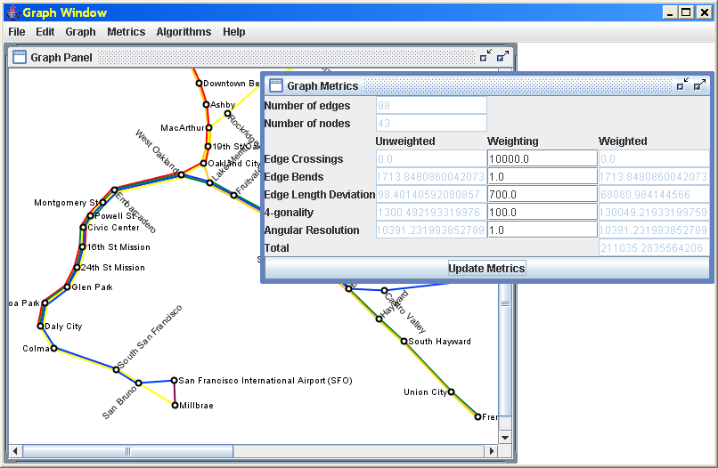
Figure 3.9. Screenshot of the schematics software tool

Preprocessing – Graph Contraction
Metro maps tend to have a certain characteristic of long lines of stations radiating from a central area. These lines can usually be drawn as a single straight line. Replacing them by a single edge means the optimizer does not have to attempt to generate the straight line iteratively (which does not always occur) and means that the process has improved performance, because the number of nodes that are moved during each iteration is reduced.
The preprocessing step involves contracting the graph such that all nodes of degree two are removed from the graph and replaced by a single weighted edge. The removed nodes and edges are not considered during calculation of the aesthetic metrics. At the end of the algorithm, the contracted edges are expanded and nodes are replaced at regular intervals between the endpoints of the edge.
However, it might not be desirable in every case to contract the graph in this manner. Once an edge is contracted it merely becomes a single straight edge, losing any bends between nodes in between the end points of the contracted edge.

The Hill Climbing Optimizer
The hill climber is an iterative process. During each iteration, an attempt is made to move each node in the graph. Any nodes which satisfy the conditions for movement are moved to their new positions.
There are various ways in which moves can be made when optimizing a graph. We have experimented with random movement of nodes, however it can take a considerable time for the random positioning to find the ideal location for a particular node. Instead, we constrain nodes to the grid and calculate the metrics for each possible location in a square around the start point of the node. The size of this square area is specified at the start of the algorithm. For example, specifying a size as one will allow the node to move to any of the eight immediately adjacent grid points. The node is moved to the point showing the largest improvement to the total weighted metrics. A move is also allowed if the total weighted metric value is the same as the start point. If all the possible moves are worse than the current value for the node, no movement is made.
A cooling option is provided in order to allow the maximum distance that a node can move to decrease linearly with each iteration. The reasoning behind this is that the graph initially requires relatively large node movements to form a overall structure for the layout. In later iterations, only minor movements need to be made to node positions in order to refine the layout within the structure developed in the first iterations.
We experimented with enforcing a geographical relationship rule whereby nodes that were to the north of those nodes stayed to the north of other nodes, nodes to the east stayed to the east, etc. However, we decided that enforcing these rules was not flexible enough as there are many situations where the rule has to be broken to achieve a better layout (particularly in the case of highly connected regions of graphs).
Finally, before a movement is made, the graph is checked to make sure that the movement does not introduce edge crossings or that the node and its adjacent edges do not occlude any other nodes or edges.

Aesthetic Metrics
We implemented a total of five different metrics based on various geometric measurements that we believe affect the quality of the graph. A metric involves iterating through either all the nodes or all the edges in the graph and calculating a value for each item. These are then summed to provide the value for the metric. In order to overcome some of the problems with metric values being disproportionate, each metric value is multiplied by a weighting. Altering the weighting also allows the user to emphasize or de-emphasize particular criteria. All the metrics we implemented are invariant under scaling, so that if the graph (and underlying grid) are scaled, the value for the metric remains the same.
The five metrics that we implemented are:

Edge Crossings Metric. The edge crossings metric is defined as the total number of edge intersections. As this is typically a low number, the weighting for this particular metric tends to be significant compared to the weightings for other metrics. It can be argued that edge crossings have meaning in metro maps, representing a line that crosses another. However, as edges are represented as straight lines between stations and not as their true route, unwanted edge crossings may be inadvertently introduced into the initial layout of the graph. This metric will only remove edge crossings that are in the initial layout because node movement is constrained to never adding an edge crossing.

4-gonality Metric. The 4-gonality metric is a measure of how close edges are to being horizontal, vertical or at 45° diagonal [43]. The intention of this metric is to favour edges which are orthogonal or at a 45° diagonal. Other edges as penalized with respect to by how much an angle they differ from being orthogonal or at 45° diagonal.
The metric for a graph containing edges E is:
where (u, v) is an edge between nodes u and v, and y(v) and x(v) are the y- and x-coordinate of node v respectively.

Edge Length Metric. In order to make sure that nodes are spaced evenly along lines, it is necessary to try to minimize the length of edges in the graph. The smallest edge length will be no less than the spacing of one grid point, so edge lengths are considered as being multiples of the grid spacing.
The edge length metric for a graph containing edges E is:
where is the length of an edge and g is the grid spacing. For contracted edges, the number of hidden nodes must be taken into account. The metric is therefore modified:
where d is the number nodes of degree two that e represents. This will cause contracted edges which are too short as well as too long to contribute to the metric.

Angular Resolution Metric. This metric attempts to ensure that all the edges incident to a node are evenly spaced. For example, if the node has four incident edges, the ideal angle between each pair of adjacent edges will be 90°. Maximising the angular resolution in this way reduces the possible confusion between edges which would otherwise be drawn very close together.
To calculate the metric, the absolute value of the difference between the ideal angle and the angle between each pair of adjacent incident edges is found and summed for all the nodes v in the graph:
where deg(v) is the degree of node v and is the angle between the adjacent edges e1 and e2.

Line Straightness Metric. An obvious feature of public transport schematics is that lines should appear to pass straight through nodes much the same way as the metro line passes through the station.
In order to measure this metric, a subgraph for each line in the graph is considered and all the nodes of degree two are then found. For each of these nodes, the difference in angle between the two incident edges is found:
where is the angle between the adjacent edges e1 and e2.
Figure 3.10 shows a simple example of how the line straightness metric is calculated. The angles θ₁ and θ₂ show the angles which are measured as part of the metric.

Figure 3.10. Line straightness metric example
Therefore, if the two edges are parallel, the metric evaluates to 0. If the two edges are at right angles, the metric evaluates to 90. This will penalize edges which double back on themselves more than edges which bend only slightly.
If a node in the subgraph for a line has a degree of more than two (for example, a line that branches), the node is not included in the line straightness metric. This is because it is not obvious as to which of the edges is the main line (and should therefore be straightened) and which is the branch line.

Total Metrics. The hill climber uses the sum of the weighted metrics to calculate a value for the total aesthetic metric for any particular layout of the graph.

Dealing with Over-length Edges
One of the problems that we discovered while developing this work was that the graph would tend to form small clusters of nodes, particularly at the ends of lines or where a line branched. This is because with only moving one node at a time, the nodes at the edge of each cluster can’t move towards the rest of the graph. A feature of these clusters is that the they are connected to the rest of the graph by one (or more) long edge.
We initially tried to find the clusters using the k-means clustering algorithm. However, this method is not used because we discovered clusters are not easy to find, particularly where the number of clusters and the number of nodes in each cluster varies.
Our next approach was to limit ourselves to clusters that formed at the end of lines. These are relatively easy to find by using an algorithm to find over-length bridge edges. These are edges which are longer than one grid spacing and whose removal would disconnect the graph.
To find bridge edges, a recursive algorithm is used. Starting with an over-length edge, the graph is recursively explored starting from the two endpoint nodes of the over-length edge. If at any point the algorithm comes upon the node at the other end of the over-length edge, it can be assumed that the edge is not a bridge edge (there must have been some other route between the two endpoint nodes rather than directly along the over-length edge). If the over-length edge is a bridge edge, then the algorithm returns two sets of nodes, representing the subgraph formed at each end of the over-length edge.
Once all the over-length bridge edges are found, all of the nodes that are on the far end of the bridge edge (the smaller of the two sets of nodes) are moved so they are closer to the rest of the graph. If both sets of nodes are the same size, then one set is chosen arbitrarily. Figure 3.11 shows an example of a bridge edge where the edge b is over-length. Neither of the two end nodes of b can move towards each other without increasing the length of two or more edges. In this case, the three nodes to the right of b will be moved closer to the other four nodes as it is the smallest subset of nodes. This process is implemented as an optional step to be performed after each iteration.

Figure 3.11. Bridge edge example

Labelling
We have implemented a simple labelling strategy for station names. Station labels can be oriented in up to eight different directions, listed in order of preference: horizontally to the right of the node, horizontally to the left of the node, 45° diagonally above-right, below-right, above-left and below-left of the node, vertically above the node or vertically below the node. To determine in which orientation to place a label, each possible orientation is checked in order of preference and the first location which is clear of incident edges is used for the label. An example of labelling a map is shown in Figure 3.16. No checks are made to make sure that the label does not obscure other nodes, edges or labels.

Examples
To illustrate the performance of our algorithm, we show how it performs on three metro maps of increasing size and complexity. The Atlanta MARTA Rail map [31] is an example of a small metro map with only two lines and 38 nodes. The Washington Metro [46] is an example of a medium sized map with 86 nodes and five lines. For an example of a large metro map, we use the Sydney Suburban CityRail map [42] which has 172 nodes and seven lines. The layout of the Atlanta map is dealt with in more detail than the other two maps to show intermediate stages during the running of the algorithm.
Examples were run on a 2.4GHz Pentium 4 machine with 512MB of RAM using Java 2 v1.4.2. The running time in seconds for each map using both contracted and uncontracted edges with the metrics weightings as shown in the following sections and with ten iterations is shown in Table 1. As the complexity of the map increases, the time taken to layout the map increases. Using the preprocessing step to contract edges significantly reduces the running time of the algorithm. On most of the examples, labels have been omitted for clarity.

Map | Uncontracted Graph - Time | Contracted Graph - Time
Atlanta | 10.665 | 0.260
Washington | 161.394 | 16.865
Sydney | 1690.228 | 241.590
Table 1. Running times for the three metro map layout examples

Atlanta MARTA Rail Map
The Atlanta MARTA Rail Map is used as an example of a small metro map. It’s structure is that of a tree as it has no cycles. The initial layout of the map is shown in Figure 3.12, and like all our examples, the starting layout is the geographic position of the stations. The metric weightings used to generate this map are: edge crossings, 10000; 4-gonality 8.0; edge length 7.0; angular resolution 0.0; line straightness 1.0. Angular resolution has a value of 0.0 because it has little effect in this particular example and therefore discounting it speed up finding the final layout.
Figure 3.13 and Figure 3.14 show the graph during and after the first iteration. It is evident that only one iteration is required to remove any edges that are not 4-gonal. It can also be seen in Figure 3.14 that all the over-length edges are shortened to their shortest length. However, owing to not enforcing geographical relationships between nodes, the single-node branch at the western end of the darker east-west line has been moved to the wrong side of the line.
Figure 3.15 shows the final layout of the Atlanta map after 10 iterations. Figure 3.16 shows the same final layout, this time with labels to illustrate the labelling of station names. It is clearly a much improved layout than the initial layout shown in Figure 3.12. The overall topology of the map has been preserved. However, the darker east-west line seems to have skewed. This is partially due to the order in which the nodes are processed by the algorithm. Also, neither of the two nodes either side of the intersection with the other line can move without introducing an extra bend in the line. This is a problem that could be solved by using contracted edges.

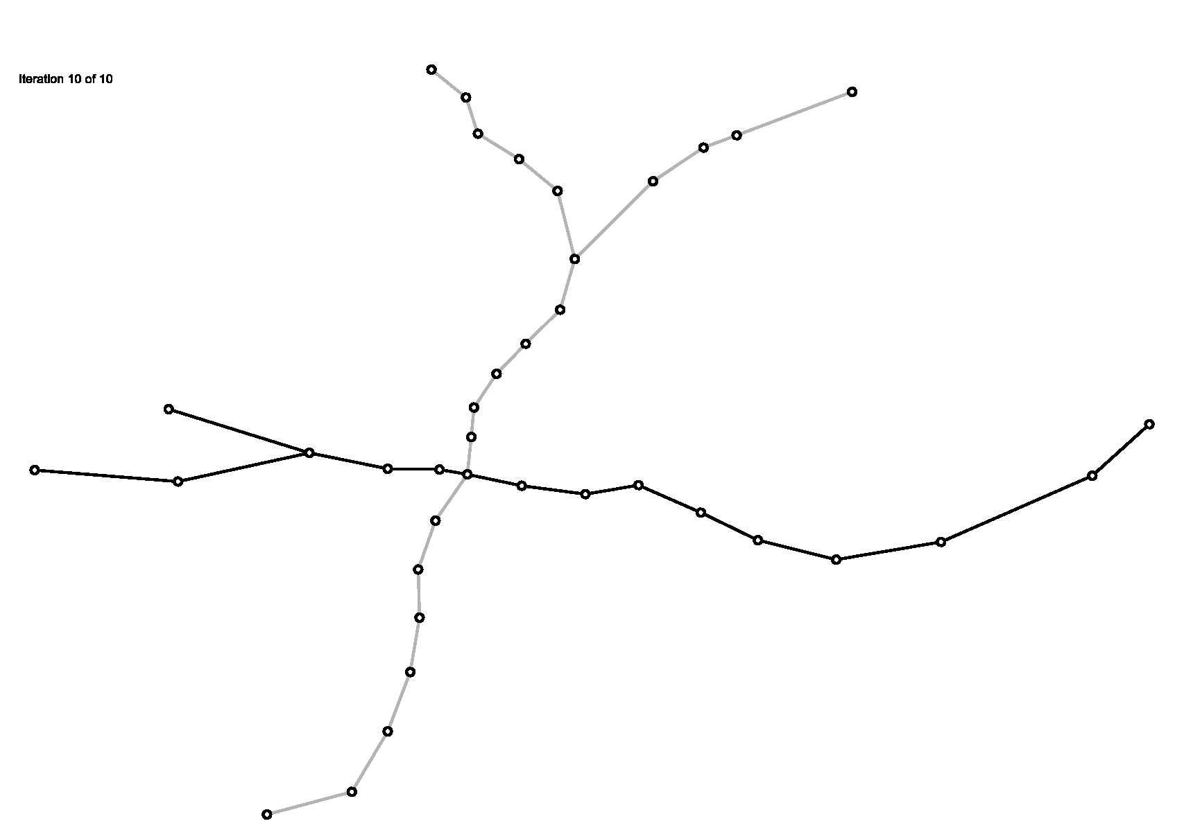  Figure 3.12. Initial layout of the Atlanta MARTA Rail map | 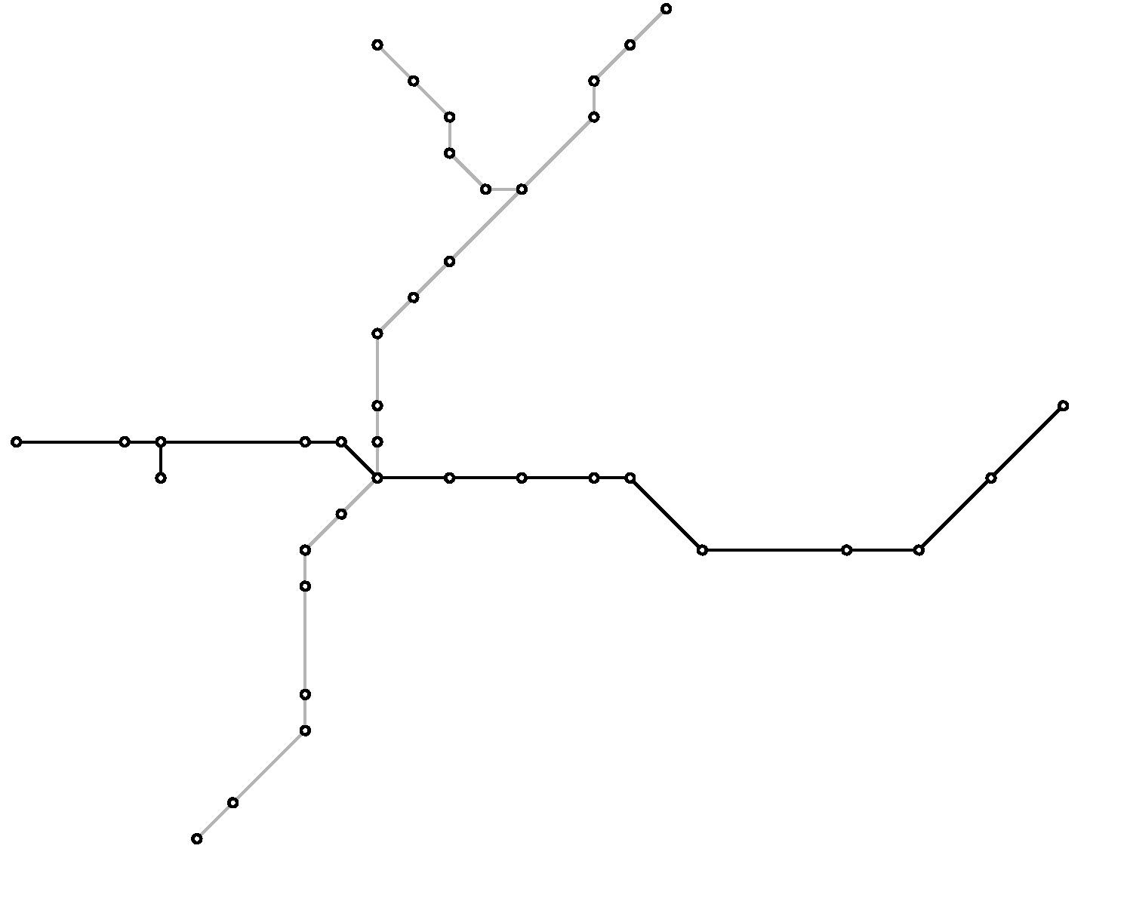  Figure 3.13. During the first iteration, before over-length edges are processed
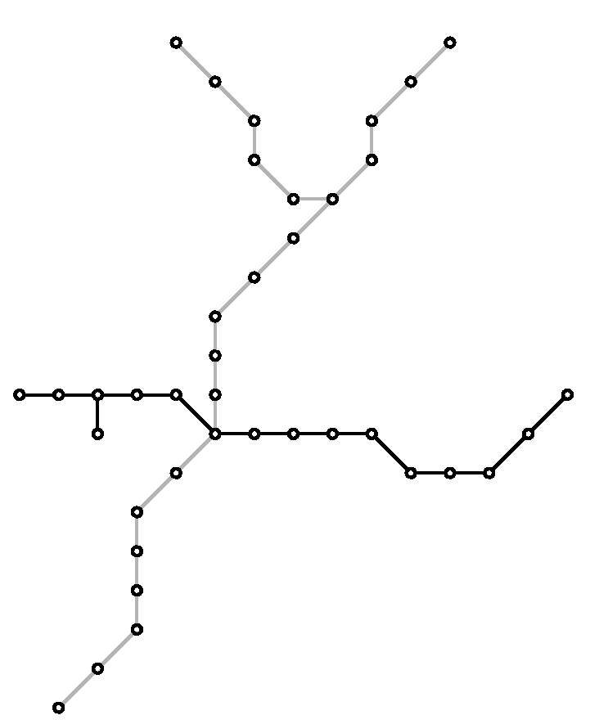  Figure 3.14. After the first iteration | 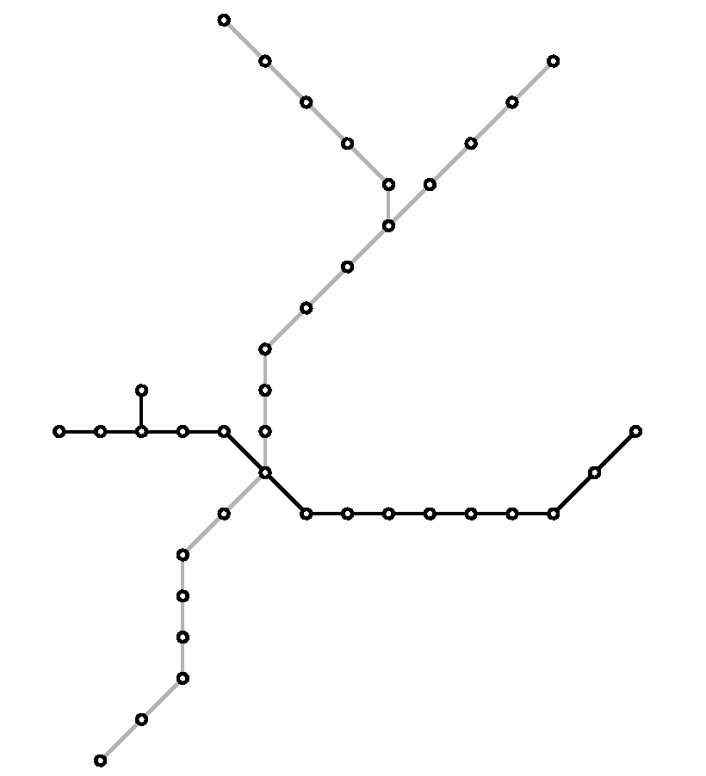  Figure 3.15. Final layout of the Atlanta MARTA Rail map
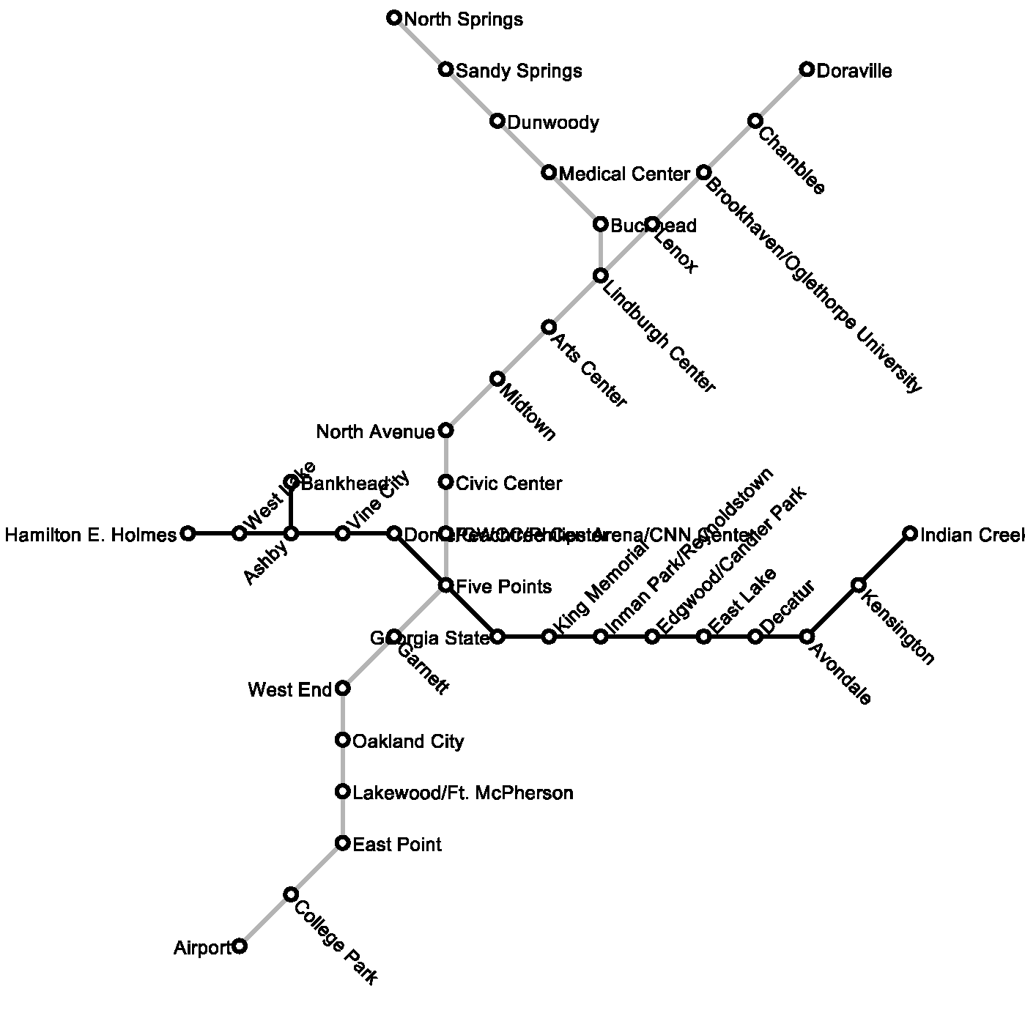
Figure 3.16. Final layout of the Atlanta MARTA Rail map with labelling

Washington Metro
The Washington Metro map is more complex than the Atlanta map. The initial layout of the Washington Metro map is shown in Figure 3.17. Of note are the introduction of loops of nodes, particularly in the centre of the map and on the two north-eastern lines. The map also has multiple edges between certain stations. For this map, the algorithm used the edge contraction preprocessing step, the result of which can be seen in Figure 3.18. The metric weightings used to generate this map are: edge crossings, 10000; 4-gonality 5.0; edge length 4.0; angular resolution 0.05; line straightness 2.0.
Figure 3.19 shows the final layout of the Washington map after four iterations. The finished graph is greatly improved from the initial graph, with lines significantly straightened and in the majority of cases each line can be followed easily enough. The resulting graph shows a problem with the loop of stations at the north-east where the loop has been significantly squashed. This problem is caused by the edge contraction stage. A possible solution to this problem would be to use one or two intermediate nodes as ‘anchor-node’ so that both halves of the loop are not totally contracted. Another problem also arises in the centre of the graph where some of the edges are drawn with a disproportionate length. However, this is also a problem for the designers of the real map, so perhaps it is unreasonable to draw each edge with the same length.

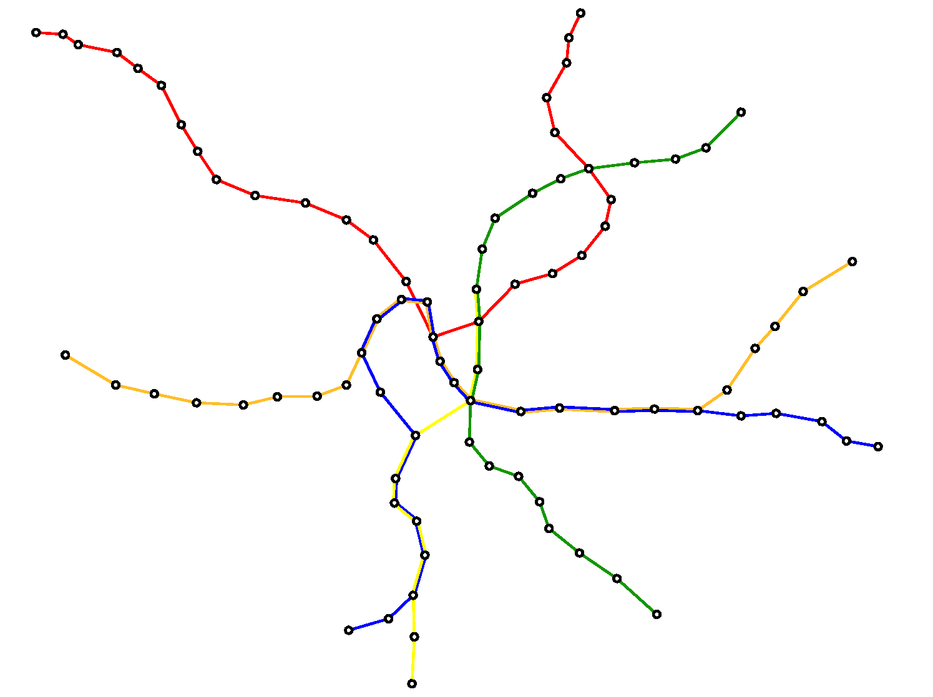  Figure 3.17. Initial layout of the Washington Metro Map | 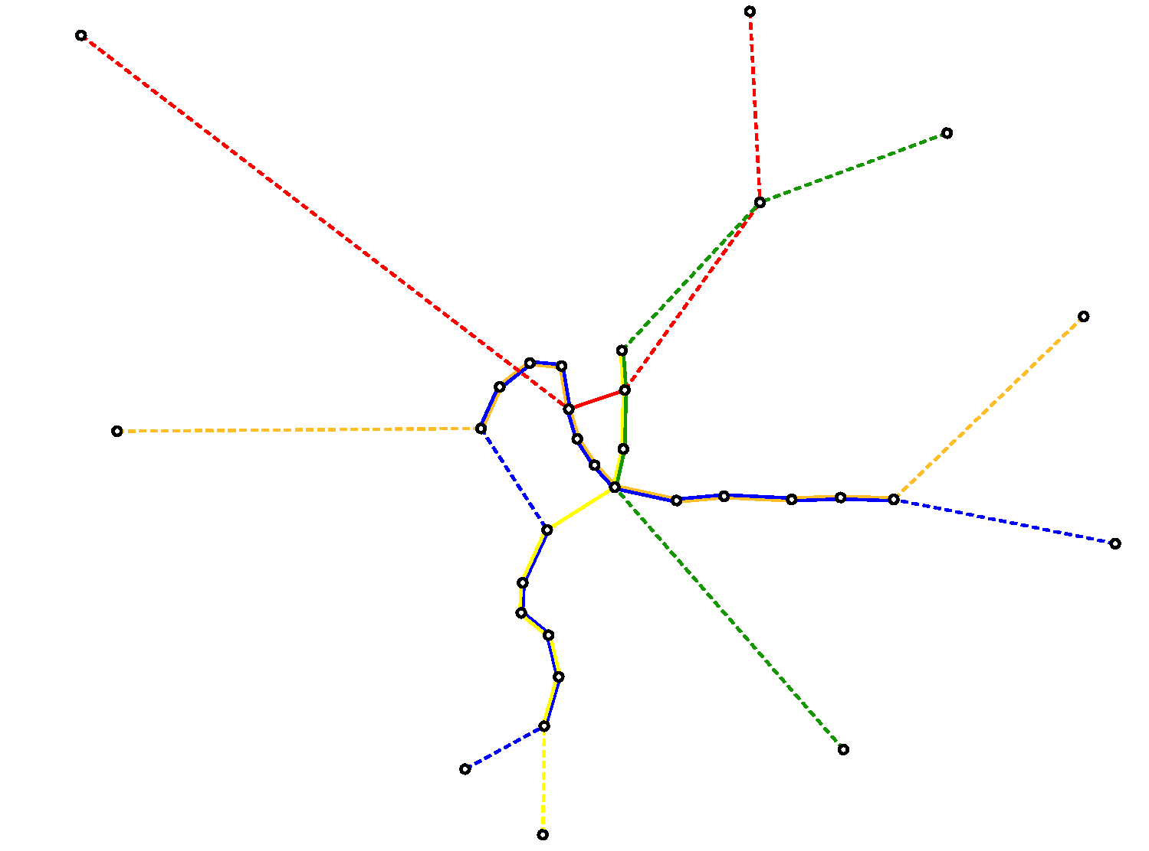  Figure 3.18. Initial layout with contracted edges (dotted edges represent contracted edges)
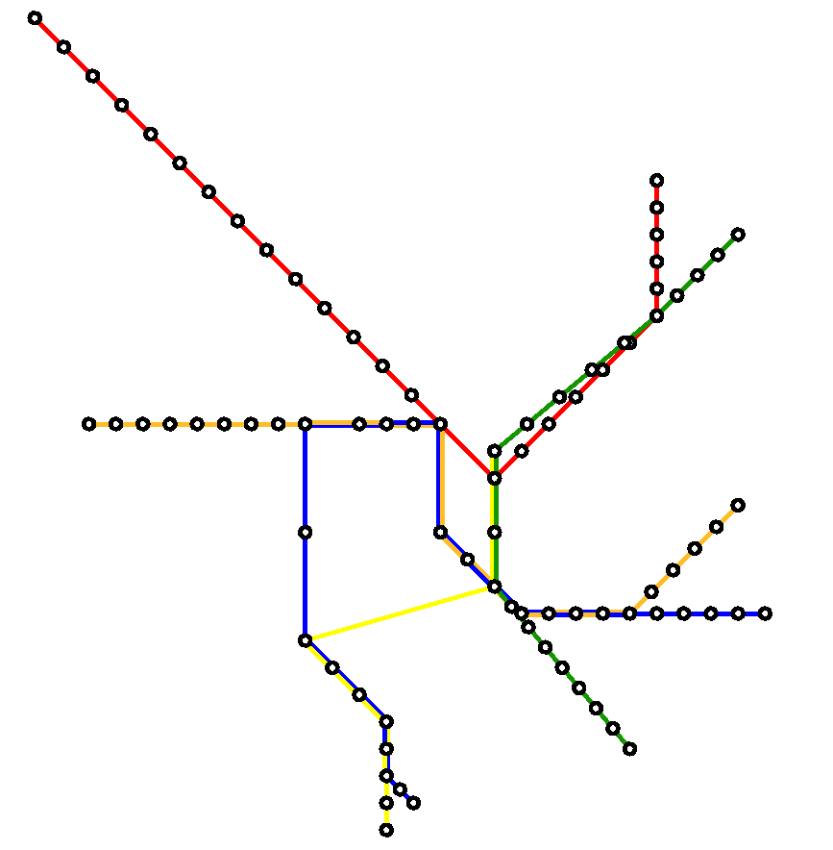
Figure 3.19. Final layout of the Washington map

Sydney Suburban CityRail
The Sydney Suburban CityRail map (shown as part of Figure 3.20) is used as an example of using our algorithm to lay out a large metro map. We only use the suburban part of the map and leave out the intercity lines such as the northernmost line. This makes it difficult to compare our results against those in [20], where a larger map is used. Figure 3.21 shows the initial layout of the CityRail map while Figure 3.22 and Figure 3.23 show two final layouts after ten iterations, the first a layout generated using contracted edges, the second without. The metric weightings used to generate this map are: edge crossings, 10000; 4-gonality 8.0; edge length 7.0; angular resolution 0.0; line straightness 1.0.

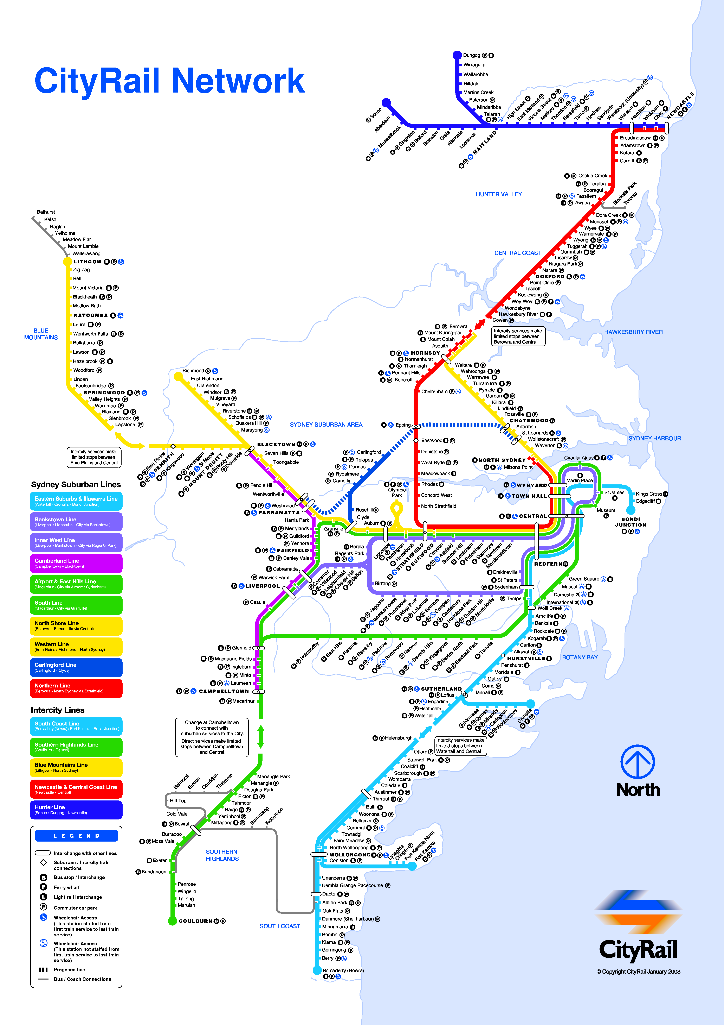
Figure 3.20. Sydney CityRail map
Both the final graphs show significant straightening of all the lines. The graph drawn without edge contraction is closer to the initial layout but at the cost of more time required to create the layout. We believe that both of the final graphs are preferable to the approximation when it comes to using them for navigation round the network.
In Figure 3.22, some contracted edges are clearly not 4-gonal. There are two possible reasons for this. Firstly, that it is not possible to move the nodes at the end of the contracted to improve the metrics without moving more than one node. Secondly, that in the case of diagonal edges, because the integer grid restricts the possible positions for nodes, which means that the best position for the endpoints of the edge is slightly offset from the 45° diagonal in order to satisfy the edge length metric. Some sections of the graph also suffer from irregular node spacing, mainly where more than one bridge edge partitions the graph.
Figure 3.23 suffers from similar problems to Figure 3.22, mainly with respect to irregular spacing of nodes along lines. Both graphs struggle to cope with the small loop in the middle on the right; the loop is excessively large in order to accommodate the small branch line inside the loop.

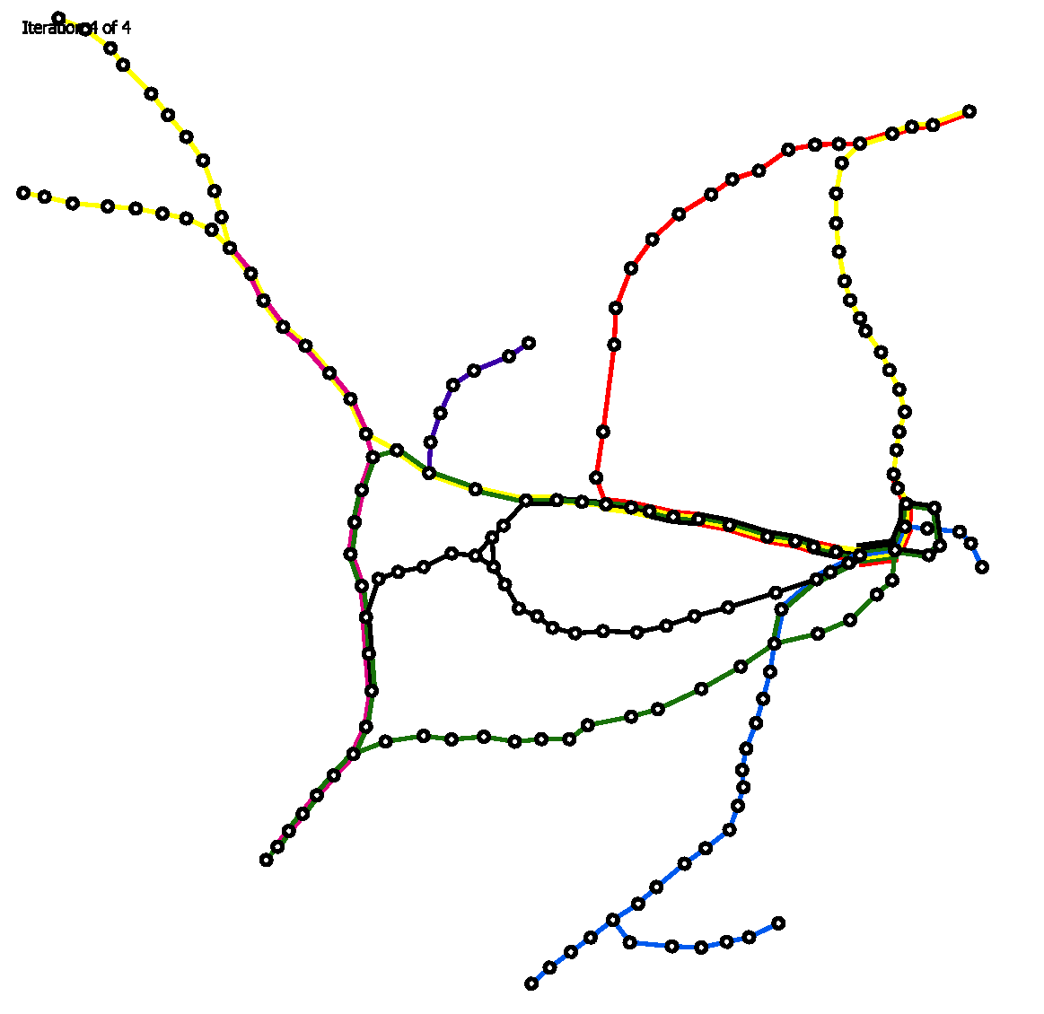  Figure 3.21. Initial layout of the Sydney CityRail map | 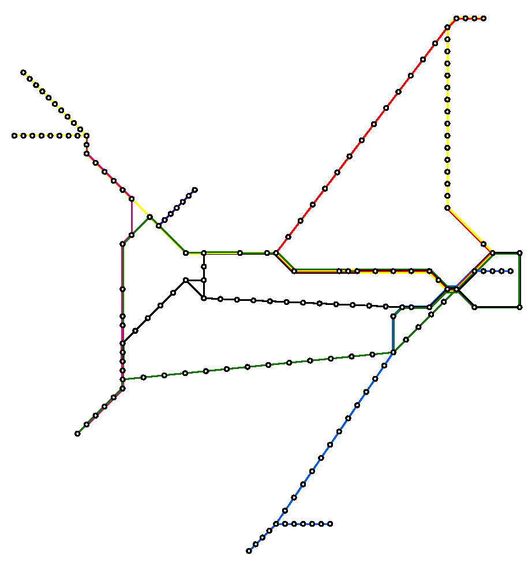  Figure 3.22. Final layout of the Sydney CityRail map using contracted edges
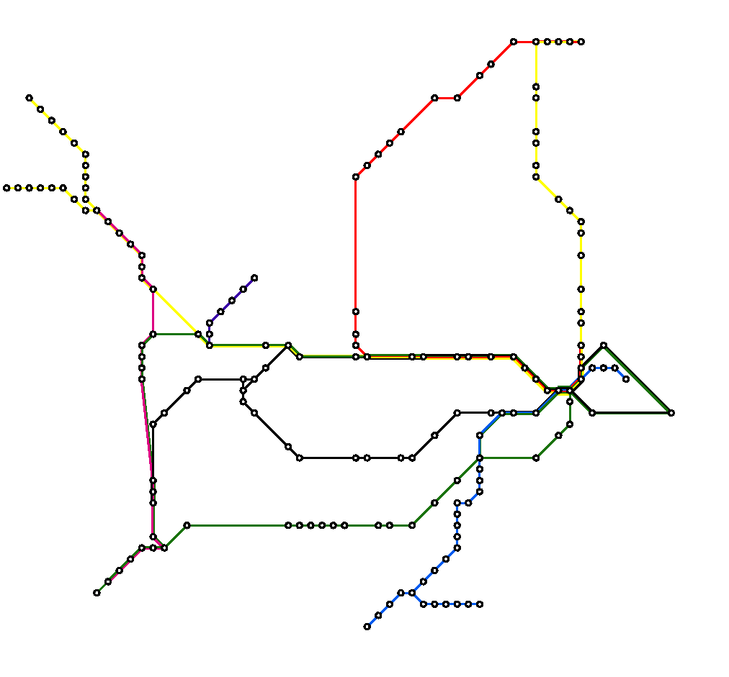
Figure 3.23. Final layout of the Sydney CityRail map without using contracted edges

Conclusion
In this paper we presented an algorithm using a hill climbing multicriteria optimisation technique to automatically generate good layouts of metro maps. We implemented a preprocessing step to contract nodes of degree two and an additional step at each iteration of the algorithm to deal with over-length edges. The final layouts of the metro maps show a significant improvement on the original geographic layout and make the maps much easier to navigate.
We believe that out multicriteria optimisation technique can be extended relatively easily with other metrics in order improve further on the quality of the final map layouts. In particular, metrics can be introduced so that station labels are positioned with regard to the rest of the map – for example, it is generally desirable when labelling metro maps that labels never obscure edges, nodes or other labels. Other metrics might include constraining the graph to a certain area or to reduce the chance that a node could move close to another edge. Another improvement would be to use polylines to draw edges that cannot be drawn either orthogonally or diagonally.
There are also other problems that need to be considered. These include dealing with highly connected maps, contracting multiedges and reducing over-length edges when there is more than one over-length bridge edge separating the graph.
As the size of the network increases, the speed of our system degrades significantly. There is a great deal of optimisation that could be implemented, for example the metrics are completely recalculated for each node movement. This could be improved by the system reusing many of the calculations in subsequent iterations. The calculations of the metrics could be speeded up by integrating the calculation of multiple metrics.
This future work is addressed in more detail in Chapter 4.

Future Work

Improvements to Existing Algorithm
A number of improvements to my existing method need to be explored to maximise the potential from the multicriteria optimisation approach. Some of these are described in this section.

Performance and Optimisation
To ease implementation of the method, all the metrics were implemented naïvely such that a significant amount of repeat calculation occurred. While performance wasn’t of paramount importance, it would be desirable to find ways in which the implementation could be optimised. This would allow for the potential use of the method for real-time applications, perhaps for dynamic map generation for the Internet or for the schematising of maps for portable devices such as satellite navigation devices [1].

Consideration of Highly Connected Maps
The examples given in Section 3.3 are of metro maps which are not highly connected, complex networks. Some maps (particularly of well-developed metro systems such as the London Underground (Figure 1.3) and the Paris Métro [36]) are very highly connected and as such are currently difficult to lay out with the current method. It would be very desirable to be able to automatically generate layouts of these maps as they are the most time consuming to draw by hand.
The main problem comes in the way that only individual nodes are moved at any one time. When the graph is highly connected, moving a node might not be possible owing to the large number of incident edges. It would therefore seem reasonable that multiple nodes should be moved simultaneously or special cases could be enumerated such that appropriate movements could be made. Finding groupings of candidate nodes for movement looks to be a difficult but interesting problem.

Improved Preservation of Geographic Interrelationships Between Nodes
The preservation of geographic interrelationships between nodes is considered as an important feature of schematic maps. In an extreme case, it wouldn’t make sense for a map of the British railway network to be drawn with Glasgow above London when Glasgow is significantly further north than London is. The current rule-based approach (see Section 3.2.3) is too restrictive and didn’t allow for a full exploration of the search space. Better methods that preserve the topology of the graph should therefore be considered.

Labelling
For metro maps, labelling is almost as essential as drawing the stations and lines themselves. Indeed, it would be impossible to use a metro map without labels! So far, labelling has been neglected as a core part of the method – the approach that is used currently (see Section 3.2.6) is naïve in that it doesn’t consider whether the labels overlap other labels, nodes or edges. In terms of metro map layout, this is a “cardinal rule” [30].
As such, it would be beneficial to somehow extend the current multicriteria approach to include criteria to take account of labels. At the simplest level, this might include metrics that measure the number of times labels occlude other labels, nodes and edges. It might also be desirable to use a metric to score the most preferable orientations and positions for the label. New operations would need to include the changing of the position or orientation of a label relative to it’s associated node.

Alternative Methods for Drawing Metro Maps
The method considered so far is a multicriteria optimisation method. While there is still a lot of potential for producing significantly improved embeddings of metro maps using this method, it would not be unreasonable to consider other methods for drawing the maps. These alternatives could be based on existing dynamic drawing methods (such as some of the orthogonal algorithms mentioned earlier) or a method not currently considered.

Application of Metro Maps to Abstract Metaphors
The applications of the work should not be purely limited to metro maps. As mentioned in Section 2.7 there are many other ideas that use metro-map style schematics as a metaphor to aid visualisation of abstract concepts. There is possibility of investigating these visualisations and possibly performing some empirical experiments to find out whether the resulting visualisations would be acceptable to users.

Characteristics of Existing Metro Maps
An interesting and potentially useful exercise would be some kind of systematic evaluation of existing metro maps (and related schematic diagrams). This could take the form of a simple human evaluation of common characteristics of various metro maps (in addition to the five aesthetic metrics that were considered) or a more methodical approach which might involve trying to find weightings and combinations of our metrics which would be required to produce the existing metro maps (a kind of backwards-engineering approach to the problem). The latter approach obviously requires a more mature algorithm, whereas the former approach could potentially be useful with regards to finding metrics that have not yet been considered.

Thesis Outline
It is difficult at this stage to set out a firm description of the likely form for my final thesis. A rough idea is given below (which is based on the structure of this mini thesis).

Chapter 1: Introduction
This chapter would involve a description of my motivation for carrying out the work of the three years. A summary of the applications of my work would also be included as well as an overview of the contributions I believe I have made and the publications which I have had published. A short summary of the structure of the thesis will also be given.

Chapter 2: Background
A bottom-up description of the background to my work. Much of this will draw on reading described earlier in Chapter 2, but with the potential for a more critical analysis. I would probably cover background reading in information visualisation as well as graph drawing and graph theory.

Chapter 3: Method
This section will describe all the work which I have completed. This would likely be in the form of a survey of my published work, with the possibility of going into more detail on some of the more complex work (where a paper might not provide enough space). There might well be a number of ‘methods’ if my work does not take a single line of approach.

Chapter 4: Evaluation of the Method
It would be necessary to compare the performance of my work with regards to existing work in the area. A thorough critical analysis of the quality of my results should also be given.

Chapter 5: Conclusions and Possible Further Work
Finally, I will conclude by summarising my work and detail any potential further work that becomes evident over the next couple of years and that I don’t get time to address.

References
- M. Agrawala, C. Stolte. Rendering Effective Route Maps : Improving Usability Through Generalization. Proceedings of SIGGRAPH 2001. pp 241-249. 2001.
- G. di Battista, P. Eades, R. Tamassia and I. G. Tollis. Graph Drawing: Algorithms for the Visualisation of Graphs. Prentice Hall. 1999.
- G. di Battista, P. Eades, R. Tamassia, I. G. Tollis. Algorithms for Drawing Graphs: an Annotated Bibliography. Available from ftp://wilma.cs.brown.edu/pub/papers/compgeo/gdbiblio.ps.Z. June 1994.
- T. Barkowsky, L. J. Latecki, K. Richter. Schematizing Maps: Simplification of Geographic Shape by Discrete Curve Elimination. Spatial Cognition II, LNCS 1849, pp. 41-53. 2001.
- F. Bertault. A Force-Directed Algorithm that Preserves Edge Crossing Properties. Proceedings of Graph Drawing 1999. Springer LNCS 1731, pp. 351-358. 1999.
- U. Brandes, M. Eiglsperger, M. Kaufmann, D. Wagner. Sketch Driven Orthogonal Graph Drawing. Proceedings of Graph Drawing 2002. Springer LNCS 2528, pp. 1-11. 2002.
- J. Branke, F. Bucher, H. Schmeck. Using Genetic Algorithms for Drawing Undirected Graphs. Third Nordic Workshop on Genetic Algorithms and their Applications, Helsinki, Finland, 20.-22.8.1997, Finnish Artificial Intelligence Society (Hrsg.), 1997, pp. 193-206.
- British Railway Maps. National Rail Enquiries. Available from http://nrekb.com/maps.htm. Accessed on 1 July 2004.
- H. Casakin, T. Barkowsky, A. Klippel, C. Freska. Schematic Maps as Wayfinding Aids. Spatial Cognition II, LNCS 1849, pp. 54-71. 2001.
- J. Christensen, J. Marks, S. Shieber. An Empirical Study of Algorithms for Point-Feature Label Placement. ACM Transactions of Graphics. Vol. 14, No. 3, pp. 203-232. 1995.
- R. Davidson, D. Harel. Drawing Graphs Nicely Using Simulated Annealing. ACM Trans. Graphics, Vol. 15, No. 4, pp. 301-331, 1996.
- C. Ding, P. Mateti. A Framework for the Automated Drawing of Data Structure Diagrams. IEEE Transactions on Software Engineering. Vol. 16, No. 5. pp 543-557. May 1990.
- P. Eades. A Heuristic for Graph Drawing. Congressus Numeratum 42.pp. 149-60. 1984.
- J. Flower, P. Rodgers, P. Mutton. Layout Metrics for Euler Diagrams. In Seventh International Conference on Information Visualization (IV03), pages 272-280. IEEE, January 2003.
- R. W. Floyd. Algorithm 97: Shortest Path. Communications of the ACM. Vol. 5, p. 354. 1962.
- U. Fößmeier, M. Kaufmann. Drawing High Degree Graphs with Low Bend Numbers. Proceedings of the Symposium on Graph Drawing. pp. 254-266. 1995.
- A. Frick, A. Ludwig, H. Mehldau. A Fast Adaptive Layout Algorithm for Undirected Graphs. Proceedings of Graph Drawing 1994. Springer LNCS 894. pp. 388-403. 1995.
- T. M. J. Fruchterman, E. M. Reingold. Graph Drawing by Force-Directed Placement. Software – Practice and Experience. Vol. 21, No. 11. pp. 1129-1164. November 1991.
- M. R. Garey, D. S. Johnson. Crossing Number is NP-Complete. SIAM Journal of Algebraic and Discrete Methods. Vol. 4, No. 3, pp. 312-316. 1983.
- K. Garland. Mr. Beck’s Underground Map. Capital Transport Publishing. England. 1994.
- S. H. Hong, D. Merrick, H. A. D. do Nascimento. The Metromap Layout Problem. Technical Report IT-IVG-2003-03, School of IT, University of Sydney, 2003.
- S. H. Hong, D. Merrick, H. A. D. do Nascimento. The metro map layout problem, in N. Churcher and C. Churcher, eds., Information Visualisation 2004, Vol. 35 of Conferences in Research and Practice in Information Technology, ACS, pp. 91-100. 2004.
- K. G. Kakoulis, I. G. Tollis. A Unified Approach to Labelling Graphical Features. 14th Annual ACM Symposium in Computation Geometry. June 1998.
- T. Kamada, S. Kawai. An Algorithm for Drawing General Undirected Graphs. Information Processing Letters. Vol. 31, pp. 7-15. 1989.
- M. Kaufmann and D. Wagner. Drawing Graphs: Methods and Models, LNCS 2025. 2001.
- M. van Kreveld, T. Stijk, A. Wolff. Point Labelling with Sliding Labels. Proceedings of the 14th Annual ACM Symposium of Computational Geometry. pp. 337-346. 1998.
- U. Lauther, A. Stübinger. Generating Schematic Cable Plans Using Springembedder Methods. Proceedings of Graph Drawing 2001. LNCS 2265. pp. 465-466. Springer. 2001.
- London Buses Spider Maps. Available at http://www.tfl.gov.uk/buses/spiders/borough.shtml. Accessed on 1 July 2004.
- London Underground network map. Available at http://tube.tfl.gov.uk/content/tubemap/default.asp. Accessed on 1 July 2004.
- M. Ovenden, Metro Maps of the World, Capital Transport Publishing, England, 2003.
- Metropolitan Atlanta Rapid Transport Authority network map. Available at http://www.itsmarta.com/getthere/schedules/index-rail.htm. Accessed on 5 March 2004.
- Z. Miller, J. B. Orlin. NP-Completeness for Minimizing Maximum Edge Length in Grid Embeddings. Journal of Algorithms. Vol. 6, pp. 10-16. 1985.
- K. V. Nesbitt. Getting to More Abstract Places with the Metro Map Metaphor. Proceedings of the 8th International Conference on Information Visualisation (IV04). IEEE, July 2004.
- A. Papakostas, I. G. Tollis. Orthogonal Drawing of High Degree Graphs with Small Area and Few Bends. WADS 1997. pp. 354-367.
- H. C. Purchase, R. F. Cohen, M. Jones. Validating Graph Drawing Aesthetics. Proceedings of the Symposium on Graph Drawing. pp. 435-446. 1995.
- RATP – Paris Métro network map. Available at http://www.citefutee.com/orienter/plans.php. Accessed on 19 July 2004.
- E. S. Sandvad, K. Grønbæk, L. Sloth, J. L. and Knudsen. A Metro Map Metaphor for Guided Tours on the Web: the Webvise Guided Tour System. Proceedings of the 10th International World Wide Web Conference, Hong Kong, May 1-5, 2001. ACM: New York, 2001. pp. 326-333.
- J. M. Six, K. G. Kakoulis, I. G. Tollis. Techniques for the Refinement of Orthogonal Graph Drawings. Journal of Graph Algorithms and Applications. Vol. 4, No. 3, pp. 75-103. 2000.
- J. M. Stott, P. Rodgers. Metro Map Layout Using Multicriteria Optimization. Proceedings of the 8th International Conference on Information Visualisation (IV04). IEEE, July 2004.
- K. Sugiyama, K. Misue. A Simple and Unified Method for Drawing Graphs: Magnetic-Spring Algorithm. DIMACS International Workshop, Proceedings of Graph Drawing 1994. Springer LNCS 894. pp. 364-375. 1995.
- K. Sugiyama, K. Misue. Graph Drawing by Magnetic Spring Model. Journal of Visual Languages and Computing. Vol. 6, No. 3, pp. 217-231. 1995.
- Sydney CityRail network map. Available at http://www.cityrail.info/networkmaps/selection.jsp. Accessed on 5 March 2004.
- R. Tamassia. On Embedding a Graph in the Grid with the Minimum Number of Bends. SIAM Journal of Computing. Vol. 16. No. 3. pp. 421-444. June 1987.
- D. Tunkelang. A Practical Approach to Drawing Undirected Graphs. Technical Report CMU-CS-94-161, Carnegie Mellon University, School of Computer Science, 1994.
- C. Ware, H. Purchase, L. Colpoys, M. McGill. Cognitive Measurements of Graph Aesthetics. Information Visualization. Vol. 1, No. 2, pp. 103-110.
- Washington Metro network map. Available at http://www.wmata.com/metrorail/systemmap.cfm. Accessed on 5 March 2004.
- P. Yates, M. Humphries. The Generation of Schematic Diagrams from Geographic Representations of Networks. Proceedings of the Spatial Information Research Centre’s 10th Colloquium. 1998.

http://tube.tfl.gov.uk/content/faq/facts.asp
This chapter is largely based on our paper presented at the 8th International Conference on Information Visualisation in July 2004 [39].

